Fidelity House Kings AAU
(2000-present)

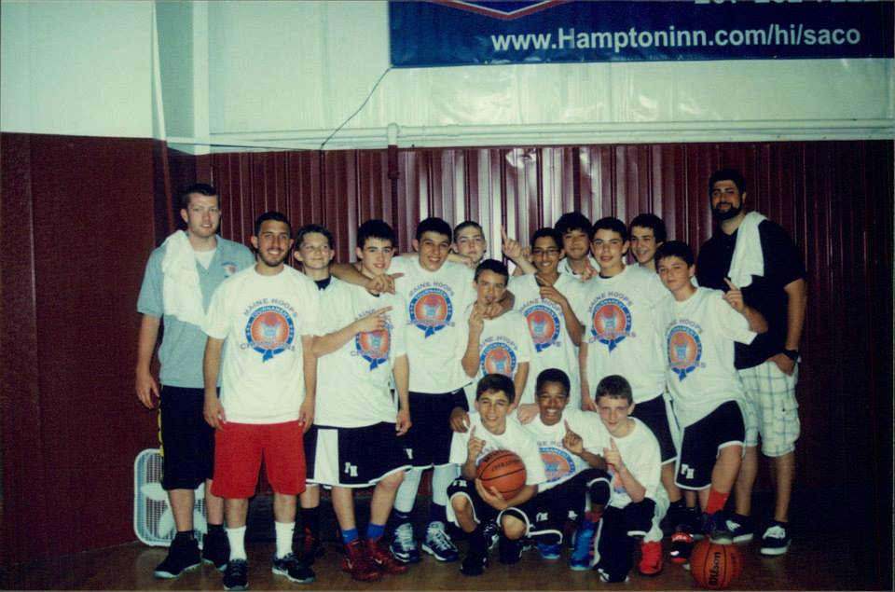
7th Grade Maine Hoop Champs

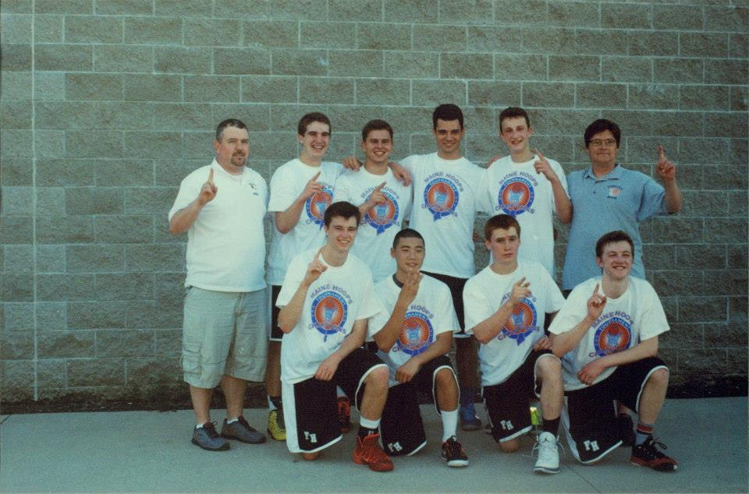
11th Grade Maine Hoops Champs

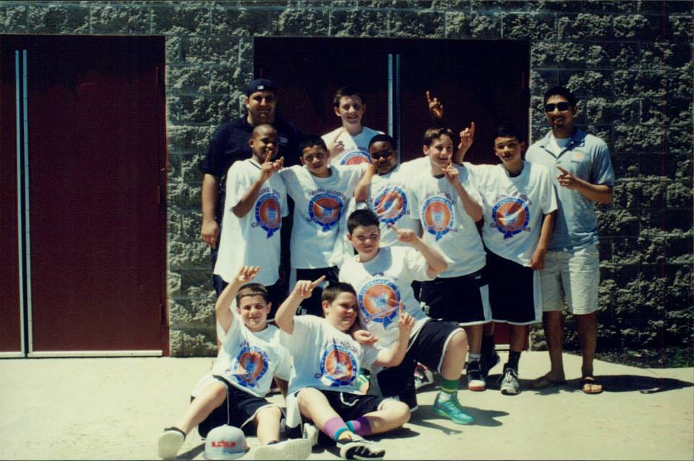
6th Grade Maine Hoops Champs

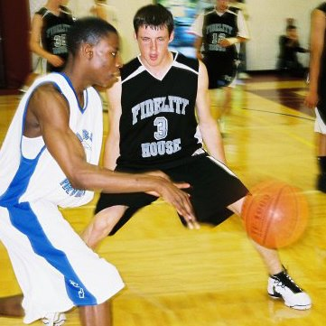
Pat Connaughton-Kings Alumni

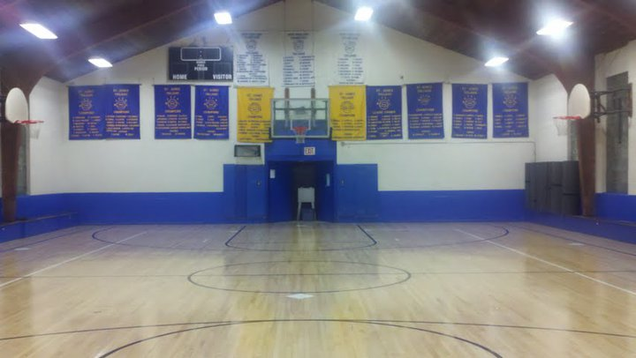
FiHo Gym

What is Fidelity House AAU?
Fidelity House Kings AAU is back for it's 16th year. We will be offering an AAU team for grades 7-12 this Fall. Our goal is to bring a positive basketball experience to all of our players while competing locally in invitational tournaments, qualifying tournaments and other events. Fidelity House looks to maintain it's strong reputation as a quality AAU basketball program within the Greater Boston area.

This Fall's AAU season will feature: weekly skills clinics for AAU participants and members of Fidelity House, each team will have 1-2 practices per week and we will be going to 3 tournaments this Fall. The AAU fee will be determined by the number of events each team decides to play in. Generally our AAU fee is much more affordable than our competitor's price. We are able to do this by having our own gym for practices, making smart decisions as an organization, having volunteer coaches and our not-for-profit mindset.

Fidelity House AAU began in 2000 with a single AAU team, and has grown each year. Former Fidelity House players have gone on to play Division I, II and III college basketball. We have had 50+ athletes play sports at the collegiate level without the luxury of multiple teams per grade or corporate sponsorship. In the meantime, lifelong friendships and relationships have been formed through the great sport of basketball. Fidelity House AAU is known for their competition level, sportsmanship and player camaraderie throughout New England. It's a tribute to the players, coaches and families that make the commitment each season.

Fidelity House AAU prioritizes team play and skill development; we are able to achieve this through quality coaching, lofty expectations (player & team) & committed players/families/coaches. A typical Fidelity House King is a gym rat who can't wait for their next practice, skills & drills clinic or open gym opportunity. This mindset leads to the Fidelity House teams' ability to compete in all circumstances against all competition.

Fidelity House is extremely proud of our former players, who routinely return as coaches or supporters of the program. We've been lucky to have 11 former Kings go on to become captains of their college team and dozens more were captains of their HS teams. A captain is someone that has the trust of their teammates as well as coaches, as high an honor as any all-league recognition in our eyes.

We look forward to meeting this Fall's Kings at upcoming tryouts!

Fidelity House Kings Honored at MBCA Awards Banquet
Fidelity House is proud to announce that the Massachusetts Basketball Coaches Association has recognized 3 players for their efforts this past season. Joe Bertrand (Saugus HS) was recognized as a member of the All-North Region All-Star team. Joe will be attending Norwich University after a stellar career at Saugus HS in which he scored over 1,000 and led Saugus to the state tournament his last 3 seasons. Liam McKersie and John Roop (Arlington HS) were recognized as North Region All-Academic performers. Liam and John captained the Spy Ponders to a 14 win season without adjusting their lofty academic profiles. Next year, Liam is doing a post-grad year at Phillips Exeter and John will be attending Clark University. Congrats to all!
http://leagueathletics.com/Page.asp?n=81969&org=mbcaorg.com

Joe Bertrand & Aaron Swenson make Boston Globe All-Scholastic
Boston Globe, Winter 2014 All-Scholastics:
Joe Bertrand Saugus, senior
In his first year in the Cape Ann League, the forward earned All-Star honors after being named a Northeastern Conference All-Star a year ago. Bertrand averaged 27 points, 14 rebounds, and 4.8 assists,finishing with a double-double in all 24 games.
Joe had a fantastic 4 year career at Saugus High School. A 2 year starter and captain, Saugus High School went to the state tournament all 4 years of Joe's high school career. Joe broke out in a major way his senior year, averaging 27 points per game and 14 rebounds per game. Joe had 12 30+ point games, a double double in all 24 games & a school record 90 three pointers (almost 4 per game). His versatility on offense was a nightmare matchup for his opponents. As a 3 year AAU player for Fidelity House, Joe helped the Kings qualify for Nationals his sophomore & junior year. His junior year, the team won the NEAAU Super Regional Silver Bracket and had a 5th place finish in Division I States. Joe will continue his playing career in college at Norwich University.
Aaron Swenson ISL: Middlesex, basketball
The guard averaged 20.0 points and 6.0 assists en route to being named a NEPSAC Class B second-team member. He scored 1,126 career points and was named ISL MVP for his terrific final season. He’ll attend Connecticut College.
Aaron helped elevate The Middlesex School in the ISL League. Winning the League MVP in the process, joining the likes of Shabazz Napier, Nik Stauskas & Fidel alumni/coach Brendan Kiernan (Brooks '94). Aaron joined The Middlesex School after playing at Arlington Catholic his freshman & sophomore year. Prior to that, Aaron helped the St. Agnes Trojans in the 2009 New England CYO title, their 3rd in 8 years. Aaron began playing AAU at Fidelity House his 7th grade year through his sophomore season. He will continue his playing career at Connecticut College.

2014 League All-Stars
Cape Ann League: Joe Bertrand, Saugus
Catholic Central: Matt Wesoloski, Arlington Catholic Lou Doherty, Arlington Catholic
Catholic Conference: Phil Leotsakos, BC High
Commonwealth: Anthony Burns, Minuteman
Dual County: Ryan Smith, Waltham
ISL Harry Roberson, Belmont Hill Aaron Swenson, Middlesex
MBIL Phil Budding, Commonwealth Academy
Middlesex League: Adam Kleckner, Belmont (co-MVP)

Kings Alumni Playing Collegiately

Class of 2009
Fran Cusick- Lesley University, Cambridge, MA
Tim Graham- Fitchburg State, Fitchburg, MA
Mike Woods- Fitchburg State, Fitchburg, MA
Mike Walsh- Salve Regina, Newport, RI
Octavio Cruz- Bunker Hill Community College, Boston, MA
Ryan McGuire- Holy Cross, Worcester, MA (football)
Ben Roopenian- Trinity College, Hartford, CT (football)
Class of 2010
*#Heman Honore- UMass-Lowell- Lowell MA
Mike Paladino, Jr.- Trinity College Hartford, CT (football)
Bobby Wronski- Northeastern/SNHU (baseball)
Tom Lang- Rutgers University, New Jersey (football)
Dave Stein - Skidmore College, Saratoga Springs, NY
Keith Rineer - Lesley University, Cambridge, MA
Class of 2011
*#Chris Hurley- St. Michael’s College, Vermont
Brad Tramontozzi- Hobart College, New York
Ralph Celestin, Castleton College, Vermont
Andrew Van Nest- Harvard University, Cambridge, MA & Boston College, Chestnut Hill, MA
Nick Halloran- Boston College/Bentley, (football)
Gaelen McGrail- UMass-Boston, Boston, MA
Class of 2012
*#Brian Emerson- Williams College Williamstown, MA
Corey Ryser- Bridgewater State, Bridgewater, MA
Brian Mahoney- Connecticut College, New London, CT
Joe Granato, Rivier College, Nashua, NH
Rom Cius, Bunker Hill Community College, Boston, MA
Dennis Woods, Fitchburg State, Fitchburg, MA
Devin Lally-McGurl, Rivier College, Nashua, NH
Cliften Bonner-Desravines- Wheaton College, Norton, MA
Matt Gaither- Bates College, Lewiston, ME
Kyle Pierce - Wheelock College, Boston, MA
Nick Friedman- Bates College, Lewiston, ME
Bobby Bellotti- Connecticut College, New London, CT
Class of 2013
Joe Wesoloski- WPI- Worcester, MA
Adam Russo- Wheelock College- Boston, MA
Class of 2014
Peter Mattera- Rivier College, Nashua, NH
Justin Conway- Bates College, Lewiston, ME
Class of 2015
*#Patrick Connaughton, University of Notre Dame,
Ryan Putney- Framingham State University, Framingham
Adam Zakaria- Tufts University, Medford, MA
Rony Charles- Syracuse University (football)
Connor Macomber, Assumption College, Worcester, MA
Class of 2016
Bob Crane, Keene State College Keene, NH
Brandon Castro, Mt. Ida College, Newton, MA
Conor Dunleavy, Bridgewater State, Bridgewater, MA
*#Quinton Dale II, Wheaton College, Norton, MA
Paul Brooks, Worcester State, Worcester, MA
Class of 2017
Matt Woods, Clark University, Worcester, MA
Frantz Pinard, Suffolk University, Boston, MA/University of Tampa, Tampa, FL
Kevin Connors, Amherst College, (Cross Country)
Michael Gelineau, UMass-Lowell/Western New England Springfield, MA
Mark Bonner, Bentley University, Waltham, MA (football)
Marcus Faison, Salem State University, Salem, MA
Class of 2018
*#Joe Bertrand, Norwich University, Norwich VT
*Aaron Swenson, Connecticut College, New London CT
Harrison Roberson, Amherst College, (baseball)
Ryan Smith, Endicott College, Beverly, MA (football)

* Boston Globe All-Scholastic
# Boston Herald All-Scholastic

Fidelity House AAU Coaching Staff
Fidelity House has been extremely fortunate to have a great staff each season. The level of dedication these coach’s show toward the program and their players is a tremendous asset to Fidelity House. Fidelity House has had former coaches go on to become high school varsity coaches and college coaches at every level.

Mike Paladino- Director of Basketball Operations- AAU Head Coach-Skills & Drills Co-Coordinator-
“Coach Pal” co-founded the Fidelity House Kings back in 2000 with Fidelity House Executive Director Ed Woods and former coach Mario Deieso. The vision was to get kids playing more basketball, competitively in a local setting. Coach Pal has been a volunteer coach, advisor & mentor to many Fidelity House players and coaches. He played collegiately at Assumption College, saw his three children come through the Fidelity House AAU program, Mike Jr, Cara & Jill. Coach Pal was the Head Coach at Malden Catholic for 4 seasons and his AAU teams are known throughout the years for their competitiveness and sportsmanship. Coach Pal has coached multiple teams to national qualifiers and competed at tournaments such as the Providence Jam Fest, AAU Super Regionals & State Tournaments.

Jack Woods- Athletic Director at Fidelity House- AAU Director/Coach- Skills & Drills Co-Coordinator- Jack has coached teams at Fidelity House since 2002 and worked full time at Fidelity House since 2001. Jack is the associate head coach at Arlington HS and coached one season with Coach Pal at Malden Catholic. Coaching at Fidelity House has been a great experience over the years, working with players such as Heman Honore, Mike Paladino Jr and Pat Connaughton has been tremendous but it’s the other kids that dedicate their time to the game to be able to make a HS team that matter as well.

Rob Scaro- AAU Head Coach- Rob has been with Fidelity House since he ventured back to Arlington with his family a few years back. He dedicates a lot of time with his teams and they have been to Division III Nationals the past 2 summers in Hampton, Virginia. Rob is currently the assistant coach at Lexington Christian Academy and 5th grade travel team coach at FiHo. His sons Trey and Jack both play basketball at Fidelity House and love the game.

Adam Russo- AAU Head Coach- Adam is a staff member at Fidelity House and in his second season as an AAU coach. Adam graduated from Wheelock College where he played on the basketball team. A former Fidelity House King himself, we’re lucking to have Adam devote his time and energy into our basketball program.

Brian Rojo- AAU Coach- Brian has volunteered countless hours at Fidelity House over the years, starting with the Intramural basketball league back in the day all the way up to the NBL this past summer. Brian brings a lot of enthusiasm & years of basketball experience to the gym every day. Brian’s three sons Wyatt, Emmit & Aidan have all played basketball at Fidelity House through the years.

Alex Aiello- AAU Coach- Alex has been a full time staff member at Fidelity House and basketball coach for over 5 years, working with kids at various age levels. In the winter, Alex is the head boy’s JV coach at Arlington Catholic. Alex’s patience and competitiveness are two strengths he brings to the table every day.

Will Rury- AAU Coach- Will is in his 2nd season as coach at Fidelity House. A graduate of Arlington HS, Will currently works at Hardy School during the year. Will is a basketball junkie who is a real asset to the program at Fidelity House.

